1. [5 pts] Click on the IPv4 tab to examine the IPv4 conversations in this trace file. Based on the bytes count, what IP addresses participate in the most active IPv4 conversation and what is the bytes counts? Insert screen shot to show
   * 24.6.173.220 and 202.96.25.95

IP of most conversation (both directions ) by a pair of IP addresses : 24.6.173.220 and 202.96.25.95 🡪 9940 Bytes count

1. [5 pts] Right-click on the most active TCP conversation and select Apply as a Filter — Selected — A

B. Wireshark automatically creates and applies a display filter for this TCP conversation. How many packets match this filter (at the status bar: the bottom of Wireshark main window): **1668**

[5 pts] How much aggregate traffic (total bytes) went to/from Santa Clara, CA? **711k bytes sent**

1. [5 pts] What other message did you find (different than Q4)? **Sniffing the glue that holds the internet together**

1. [5 pts] What other message did you find (different than Q4)? **Sniff free or Die.**

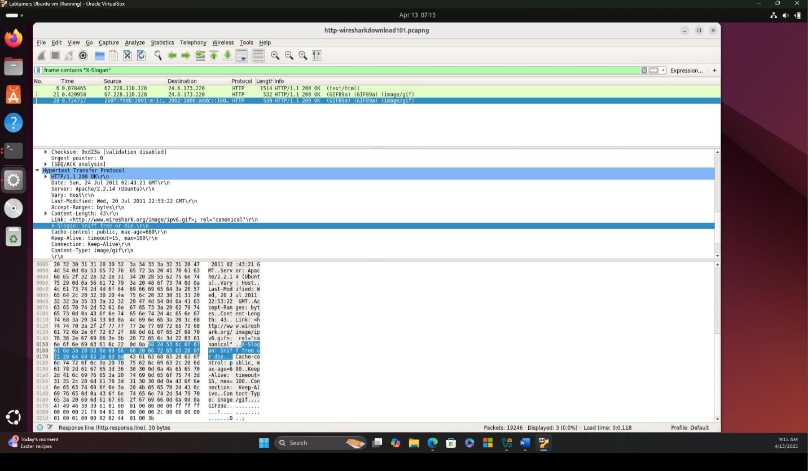

1. [5 pts] Now you only see the data channel traffic. Frames 16 through 18 and frames 35 through 38 are TCP handshake packets to establish the two required data channels. Right-click on frame 16 and select Follow — TCP Stream. This stream list indicates there is only one file in the directory. What is its name? (You will use it next.)

**Pantheon.jpg**

